1. **Touchscreen.**

**Troubleshooting and fixes:**

**Check how touch option performs on administrator when using paint**

1. **Is it recording touch but is not aligned properly?**

**Solution: Calibrate it using ELO software**

1. **It is recording touch, showing white circle on point touched, however won’t interact with software on screen.**

**Solution: restart “Tablet PC input service” in services**

1. **It works fine on administrator but not on vista.**

**Solution: Change “AutoClickNavigation=” in Kiosk.ini to opposite value than it is currently set (“N” to “Y”).**

If the touchscreen is not responsive:

Re-log to administrator

Open paint and ask person on the other end to draw something trying to cover as wide area of the paper as possible:

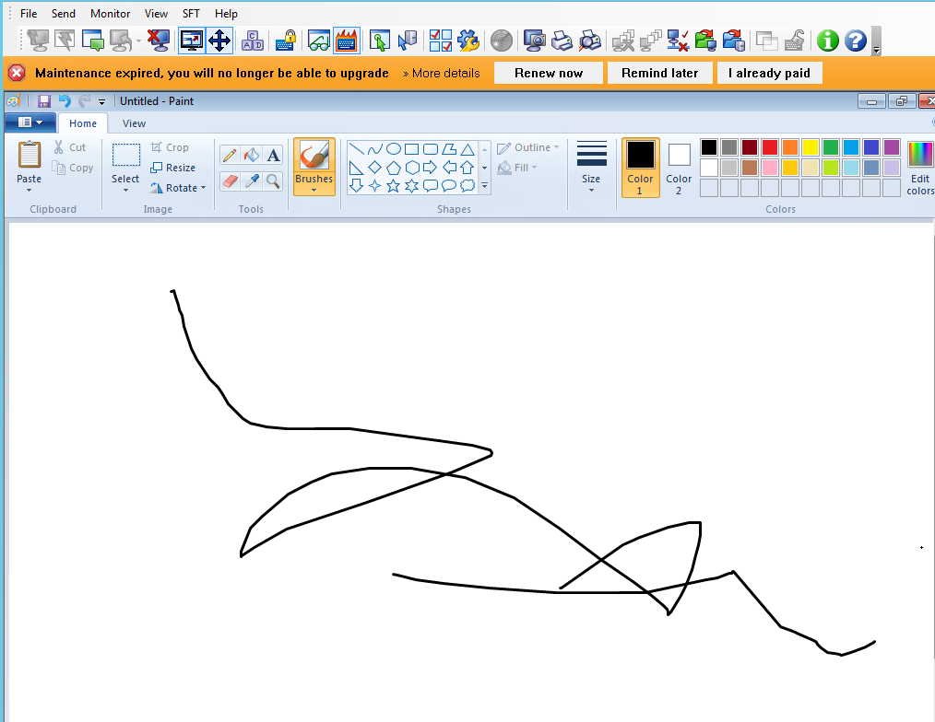

There may be 3 different outcomes for this test:

1. **If the screen is not calibrated properly/ there is a gap between point touched and point recorded on the screen- calibrate the screen**

Calibrate the screen by clicking ELO icon in right bottom corner of the screen, select align and run the calibration.

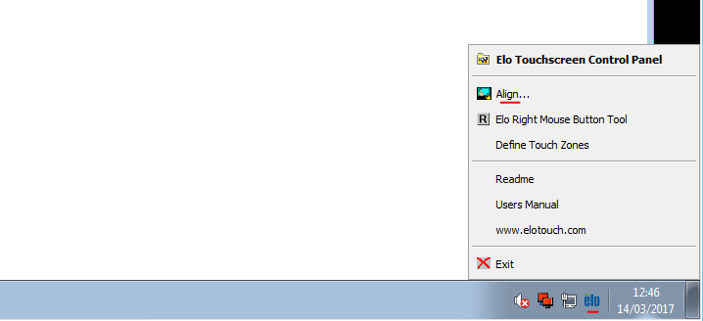

Cross hair on the screen should be touched and pressed by a finger.

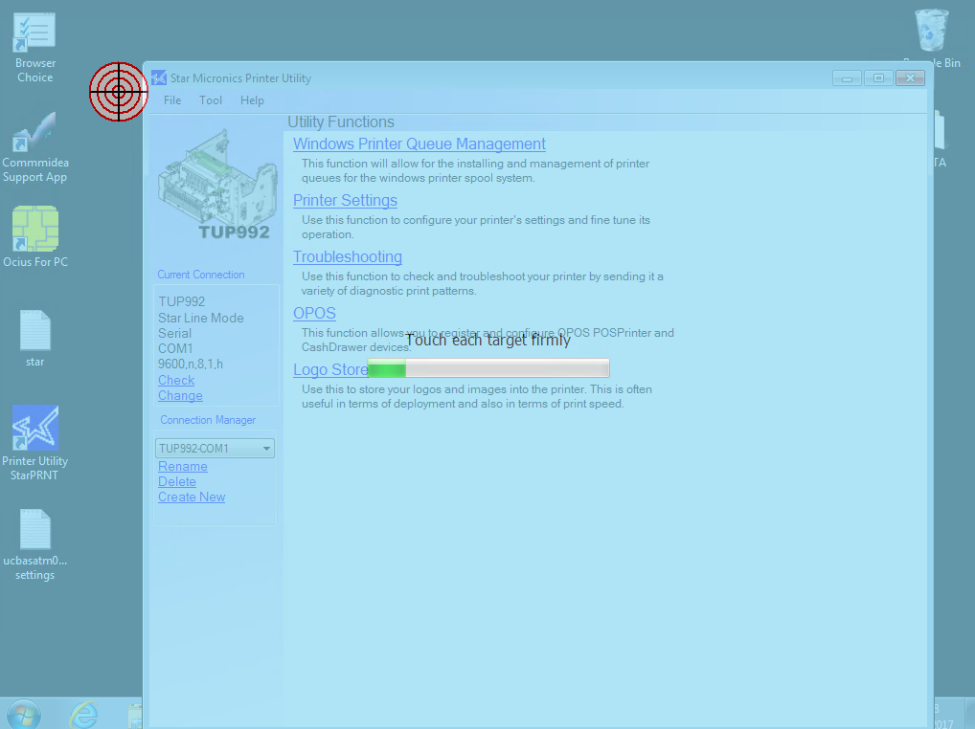

After calibrating reboot the ATM.

1. **If the screen does not record any commands on the software (it won’t leave a mark on paint for example) however you will see the screen reacting to touch in the place touched (very often there will be a white circle appearing around the place touched)**

**Fallow the fix bellow:**

Go to services-> Find “Tablet PC Input Service” and restart it

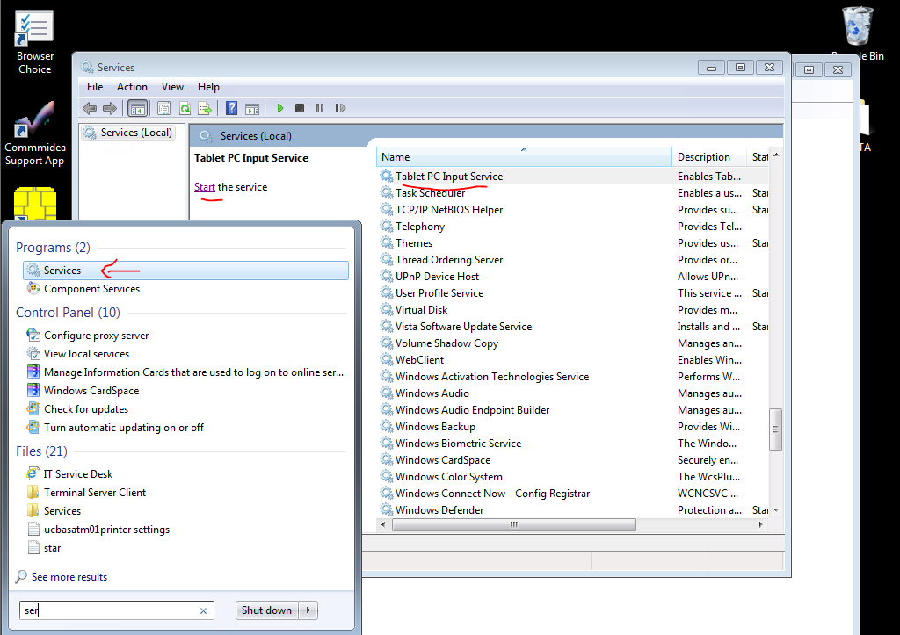

1. **Touchscreen works perfectly on administrator, however it will still be not responsive on vista.**

**Go to C:\VISTA\VistaKiosk\Config, and open KIOSK.ini**

**Under [Appearance] check the last string “AutoClickNavigation=Y”**

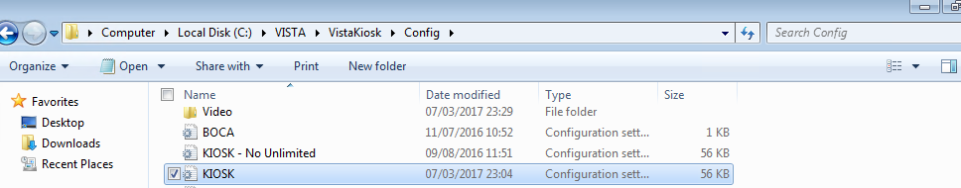

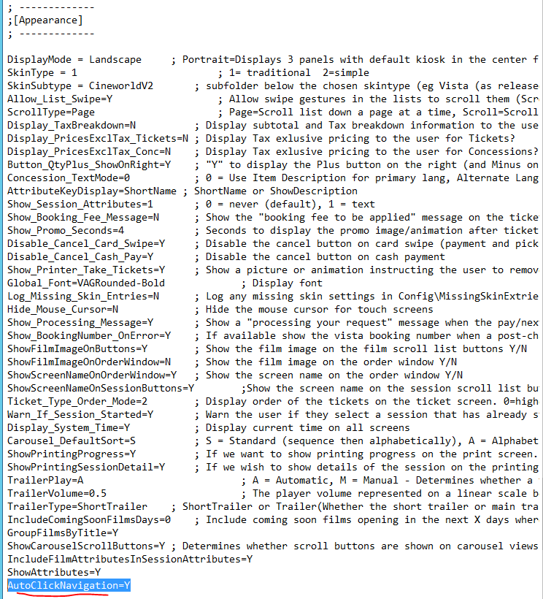

**If “AutoClickNavigation=” is set to “Y” change it to “N”**

**Adding this version may help if it is absent from kiosk.**

**However on some versions of vista it will cause troubles (example West India Quey).**